|<|<

Inter Roller Engineering Limited
Baggage Handling System
BHS Report Viewer Installation Instruction

Document No.: SAC Installation
Project No.: S01C06310Y
Author: XJ
Release Date: 19-Dec-2007
Revision: 1.03
Pages: 12

Contents
Page
Contents 2
1. Overview 3
2. Release 1.0.2 (07 Dec 2007) 4
2.1 Pre-requirement of Installation 4
2.1.1 Server Hard Disk Partition Requirement 4
2.1.2 Microsoft .NET Framework (V2.0) Requirement 4
2.1.3 Microsoft ReportViewer Control Requirement 5
2.2 Installation Instruction 8
2.3 Post Installation Instruction 9
2.3.1 BHS_ReportViewer XML Configuration File [CFG_Reporting.xml] 9
3. Release 1.0.3 (19 Dec 2007) 12
3.1 What’s New in this Release? 12
3.2 Instruction Instructions 12
3.2.1 Fresh Installation 12
3.2.2 Upgrading from Previous Release 12

Overview
This document is the installation instruction of following SAC applications:
- BHS_ReportViewer – BHS Report Viewer Application

Application File Folder Hierarchy
No | Folder | Files | Remark
1 | C:\Inter-Roller\BHS\SAC\Bin | 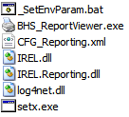 | - Application files need to be installed in the C: drive;  - Directory of all application files (.EXE), function libraries files (.DLL), and application XML configuration files (.XML).
2 | C:\Inter-Roller\BHS\SAC\Bak | *.* | Folder to backup previous version of application and configuration files before the new release files are installed.
3 | D:\Inter-Roller\BHS\SAC\Log | *.log | - System log files need to be installed in the D: drive;  - Directory of SAC application log files (.LOG).

Release 1.0.2 (07 Dec 2007)
This installation guide is for IREL BHS Report Viewer application (BHS_ReportView) only. In order to view the BHS report after the installation and configuration of report viewer application, the SQL Server Database and Reporting Service must be prior installed and configured properly.

Pre-requirement of Installation

Server Hard Disk Partition Requirement
SAC servers shall have C: and D: two partitions. SAC application files will be installed in the C: drive. All logs that are created by SAC applications during the running time will be stored in the D: drive.

Microsoft .NET Framework (V2.0) Requirement
Microsoft .NET Framework version 2.0 is required by BHS_ReportViewer applications. If SAC server do not have .NET framework or it is not version 2.0, you can download it from Microsoft web site and install it before proceed the SAC installations below.

Below picture shows how to check whether you have installed the v2.0 .NET Framework.
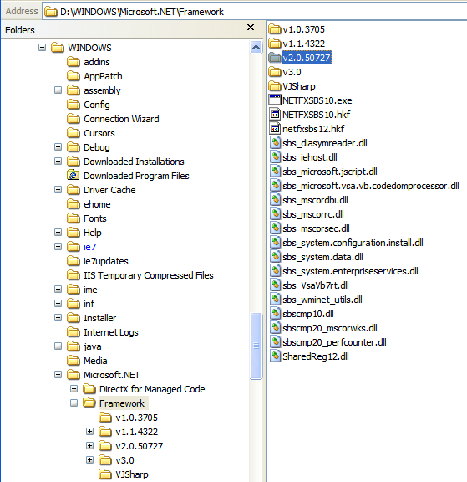

Microsoft ReportViewer Control Requirement
The Microsoft ReportViewer Control need to be installed before run the IR BHS_ReportViewer application.

The ReportViewer control redistributable is a self-extracting file named ReportViewer.exe that includes an .msi and other files. You can find ReportViewer.exe at the following location of BHS_ReportViewer deployment media:
\BHS_ReportViewer_R?.??_yyyy-mm-dd\ MSReportViewer\

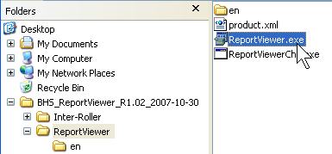
Double click “ReportViewer.exe” to start the installation.

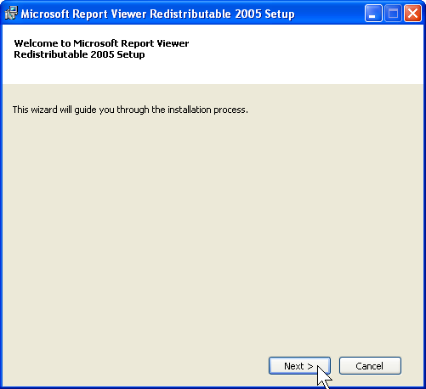
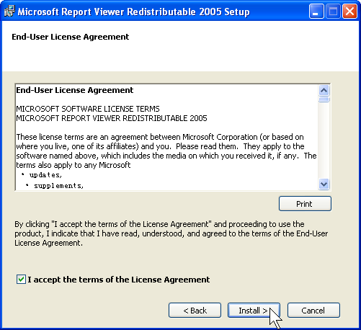

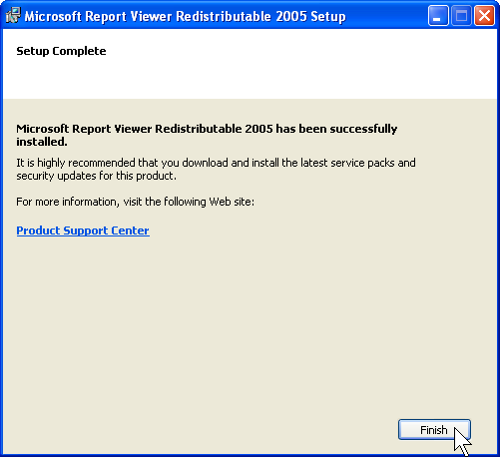

Note:
If the Microsoft ReportViewer Control is not installed, follow exception will be occurred when you try to preview report from IR BHS_ReportViewer application:
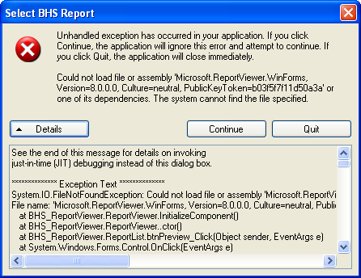

Installation Instruction
Step 1: Create folder “C:\Inter-Roller\BHS\SAC\Bin” on SAC server;

Step 2: Copy following files from installation media into server folder “C:\Inter-Roller\BHS\SAC\Bin”:

Step 3: From Windows Explorer on the server, use mouse double click file “C:\Inter-Roller\BHS\SAC\Bin\_SetEnvParam.bat”. This batch file will create following two (2) Windows system environment parameters, which will be required by all SAC services, automatically:
- IR_BHS_BIN = C:\Inter-Roller\BHS\SAC\Bin
- IR_BHS_LOG = D:\Inter-Roller\BHS\SAC\Log

Step 4: Modify XML configuration files according to the actual setting of BHS project. Please refer to section 2.3 (Post Installation Instruction) for the configuration file details.

Step 5: Restart SAC server to complete the installation process.

Post Installation Instruction

BHS_ReportViewer XML Configuration File [CFG_Reporting.xml]

Notes:
- Report Name & Type Rule:
- If the “enabled” attribute of <report> node is Fault, this report name will not be displayed in the report list on the BHS_ReportViewer application GUI.
- The same report name can be assigned to the “name” attribute of <report> node. But their “type” attribute must be assigned with different value, and it cannot be empty value. The same report name can have up to 6 types.
- Report Parameter Rule:
- <params> node defines the default value of report parameters. If they are defined at here, these default values will be passed to report template. You can also omit them. If do so, there is no default values will be passed to report template.
- If the data type of <param> node is DateTime, it's value represents a number of whole and fractional hours offset from the current date and time. It can be negative or positive value.
- The valid <param> node datatype are: String, DateTime, Integer, Boolean, Double.
- Report Group Rules:
- Multiple <reports> node can be defined by multiple "reports" node, but their "group" attribute must be different.
- If <reports> node "group" attribute is empty, the default name "Group?" will be displayed on BHS_ReportViewer GUI. "?" here is the sequence number that <reports> node in the XML file.
- The same report name and type can be appeared in the different report groups, but not in the same group.
- The reports group name or report name must not contain "\" string.

Following highlighted parameters need to be modified according to the actual configuration of individual project. All other parameters should not be modified.

<!--BTS Service Application Configuration-->
<application name="BHS_ReportViewer">
<!--Configuration Parameters that are divided into different configSet-->
<configSet name="Application.Initializer">
<company>Inter-Roller</company>
<department>CSI</department>
<author>XuJian</author>
</configSet>
<log4net>
<!-- This section contains the log4net configuration settings -->
<!-- Define some output appenders -->
<appender name="RollingLogFileAppender" type="log4net.Appender.RollingFileAppender">
<param name="File" value="${IR_BHS_LOG}\\ReportViewer.log" />
<param name="AppendToFile" value="True" />
<param name="DatePattern" value=".yyyyMMdd" />
<param name="RollingStyle" value="Date" />
<layout type="log4net.Layout.PatternLayout">
<param name="ConversionPattern" value="%d %-5p - %m%n" />
</layout>
</appender>
<!-- Setup the root category, add the appenders and set the default level -->
<root>
<!-- Level value can be ALL, DEBUG, INFO, WARN, ERROR, FATAL, OFF -->
<level value="OFF" />
<appender-ref ref="RollingLogFileAppender" />
</root>
</log4net>

<configSet name="Reporting">
<!-- Global Report Server URL. Individual report can has own reportServerUrl node, so that your
can print the reports that are located in the different report servers. If the individual report
don't have reportServerUrl node, this global report server URL will be used. -->
<reportServerUrl>http://iFix/ReportServer </reportServerUrl>
<!-- Set the display mode of ReportViewer object. True: PrintLayout, False: Normal Layout. -->
<showPrintLayout>False</showPrintLayout>
<!-- autoCloseViewer decide whether the report window to be closed automatically or not when it lose focus. -->
<autoCloseViewer>False</autoCloseViewer>
<!-- reportListStyle, 1: ListBox, 2: TreeView -->
<reportListStyle>2</reportListStyle>
<!-- displaySingleGroupName decide whether the group name is shown in the TreeView if there is only one report group -->
<showSingleGroupName>False</showSingleGroupName>

<reports group="MDS">
<report enabled="True" type="Statistic" name="Equipment Fault Report">
<reportServerUrl>http://iFix/ReportServer </reportServerUrl>
<reportPath>/BHSReports/EquipFault_ST</reportPath>
<params>
<param name="DTFrom" datatype="DateTime" value="-24"></param>
<param name="DTTo" datatype="DateTime" value="0"></param>
</params>
</report>
<report enabled="True" type="Detailed" name="Equipment Fault Report">
<reportPath>/BHSReports/EquipFault_DT</reportPath>
<params>
<param name="DTFrom" datatype="DateTime" value="-24"></param>
<param name="DTTo" datatype="DateTime" value="0"></param>
</params>
</report>
<report enabled="True" type="" name="Network Device Alarm Report">
<reportPath>/BHSReports/NetworkAlarm</reportPath>
</report>
<report enabled="True" type="" name="Audit Report">
<reportPath>/BHSReports/Audit</reportPath>
</report>
<report enabled="True" type="" name="Top Faults Report">
<reportPath>/BHSReports/TopFaults</reportPath>
</report>
<report enabled="True" type="" name="Top Faulted Equipment Report">
<reportPath>/BHSReports/TopFaultEquip</reportPath>
</report>
</reports>
<reports group="MDS">
....
</reports>

</configSet>
</application>

Release 1.0.3 (19 Dec 2007)

What’s New in this Release?
- (BHS_ReportViewer.exe) Allow both ReportList and ReportViewer windows to be shown on the Windows Taskbar.
- (BHS_ReportViewer.exe) If any system exception occurs when preview the selected report, the preview window will be closed first before display the error message box. It is to prevent the error message box to be hidden by the preview window whose top most window property is ture.

Instruction Instructions

Fresh Installation
If BHS Report Viewer is installed first time, please following the instructions as release 1.0.2 (07 Dec 2007).

Upgrading from Previous Release
If the server has already been installed with previous release of BHS Report Viewer application, then
- Close the BHS Report Viewer application if it is currently running;
- Backup all files in the server directory “C:\Inter-Roller\BHS\SAC\Bin”;
- Copy all the files listed below from new release deployment media into server directory: “C:\Inter-Roller\BHS\SAC\Bin” to overwrite the existing files.

